Daily Report

To join our research group on TELEGRAM, please click on the links - https://bit.ly/3PgiJFX and https://bit.ly/3HuYYIU

Tuesday, 20th Dec 2022
72.15.54

Indian Indices Last Price (%) Chg  NSE 18420.45 0.83  BSE 61806.19 0.76  World Indices Last Price (%) Chg  Dow Jones 32757.54 -0.49  Nasdaq 10546.03 -1.49  Nikkei 27311.50 0.27  Hang Seng 19251.50 -0.03  FTSE 7361.31 0.40  Commodity Last Price (%) Chg  GOLD($/ounce) 1795.50 -0.12  Silver ($/Ounce) 23.25 0.25  Crude ($/BBL) 76.22 1.11  Aluminium spot ($/mt) 2375.50 0.02  Copper SPOT ($/mt) 8295.50 -0.05  Zinc ($/MT) 3022.00 -0.41  Natural gas $/MMBtu 5.85 0.24  Currency Last Price (%) Chg  USDINR 82.65 -0.06  EURINR 87.71 0.23  Bond Last Price (%) Chg  India 10 Yr Bond yield 7.29 0.29  52 Wk High (A group) 52 Wk Low (A group)  Company Close Price 52 Company Close Price 52 Wk Low  Wk High  ADANIENT 4100 4105 AUROPHARM 438 435  BRITANNIA 4514 4535 MPHASIS 1925 1897  ENGINERSIND 86 88 NATCOPHARM 549 548  VGUARD 271 275 SINTEX 5.77 5.77  -- -- -- -- -- --  Source: BSE | Market Technical Outlook  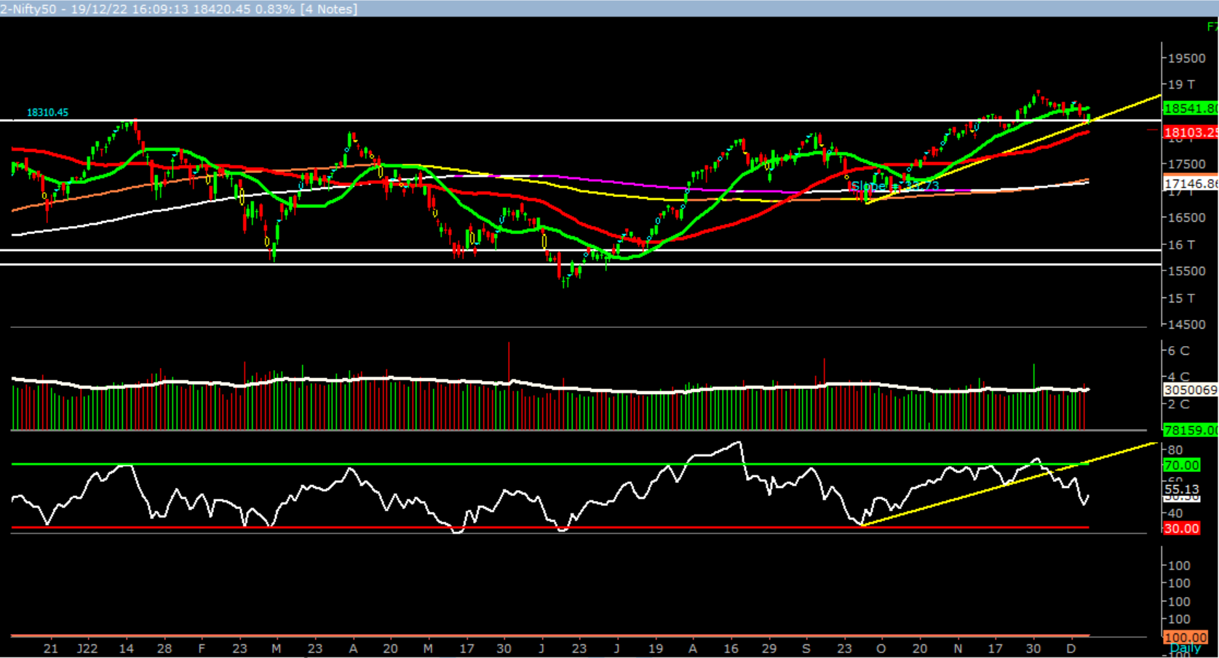  Nifty, opened higher and momentum on the upside intensified as the day progressed which led the indices to close near days high. On the daily chart, we are observing that prices have taken support at the upward sloping trendline (shown above in the graph) and formed a positive candle. This suggests that momentum on the upside is likely to continue. Incoming trading session if nifty trades above 18450 level then it may test 18550 – 18650 levels. On the downside, 18310 – 18200 may act as support for the day.  Broadly, looking at the current price action we are of the opinion that 18600 – 18700 supply zone now remains major hurdle any daily close above the mentioned supply zone would propel nifty to test 19000 – 19500 levels in couple of weeks. However, in such market stock specific activity is likely to continue  Foreign Institutional Investments (FII's) Activities  Name of Segment Net Buyer/seller Rs In Cr  Index Futures Net Buy 1155.81  Stock Futures Net Buy 1766.42  Net Future Position Net Buy 2922.23  Index Options Net Buy 3583.66  Stock Options Net Buy 236.37  Net Options Position Net Buy 3820.03  FII In cash Segment Net Sell -538.1  DII In cash Segment Net Buy 687.38  Net Cash Position Net Buy 149.28

Guru Call: From the expert’s desk
Company | Reco Date | Reco Price (Buy on dips) | High till date | Return%
Adani Power | 20-Apr-22 | 235 | 345 | 46.6%
Adani Wilmar Ltd | 20-Apr-22 | 668 | 878 | 31.5%
Aditya Birla Capital Ltd | 13-Aug-21 | 124 | 139 | 12.5%
Aditya Birla Fashion and Retail Ltd | 8-Feb-21 | 164 | 322 | 95.9%
Apcotex Industries Limited | 13-Aug-21 | 343 | 679 | 98.0%
Asian Paints Ltd. | 30-Mar-17 | 1068 | 3590 | 236.1%
Avenue Supermarts Ltd. | 31-Jul-17 | 899 | 5900 | 556.6%
Axis Bank Ltd. | 10-Apr-18 | 519 | 867 | 67.0%
Bajaj Finance Ltd | 20-Apr-22 | 7033 | 7295 | 3.7%
Bajaj Finserv Ltd | 1-Nov-16 | 3417 | 19325 | 465.6%
Bajaj Holdings And Investment Ltd | 19-May-16 | 1499 | 6598 | 340.1%
CDSL | 17-Sep-20 | 486 | 1734 | 256.9%
Chola finance | 25-Sep-20 | 239 | 770 | 222.6%
Chola Holding | 23-Sep-20 | 392 | 763 | 94.7%
Cipla Ltd | 20-Mar-17 | 597 | 1083 | 81.3%
Colgate Palmolive | 16-Sep-19 | 1314 | 1823 | 38.7%
D. P. Abhushan Ltd | 20-Apr-22 | 396 | 495 | 25.0%
Dabur India | 22-Oct-19 | 466 | 659 | 41.4%
DLF Ltd | 10-Apr-19 | 194 | 450 | 131.6%
Dr Reddy | 4-Aug-20 | 4530 | 5615 | 24.0%
Emami Limited | 26-Jun-19 | 290 | 622 | 114.2%
Finolex Cables Ltd | 8-Feb-21 | 130 | 268 | 106.2%
Fortis | 14-Jul-20 | 127 | 314 | 147.2%
Godawari Power | 20-Apr-22 | 455 | 482 | 6.0%
Godrej Consumer Products Limited | 16-Jun-20 | 634 | 1138 | 79.5%
HDFC Asset Management Company Ltd. | 19-Dec-18 | 1573 | 3844 | 144.4%
HDFC Bank Limited | 10-Nov-16 | 639 | 1725 | 170.0%
HDFC Life Insurance Co Ltd | 19-Jan-18 | 485 | 776 | 60.0%
Heritage Foods Ltd | 20-Apr-22 | 330 | 354 | 7.2%
Hero Motocorp Ltd | 29-Sep-20 | 3175 | 3629 | 14.3%
Hindustan Unilever Ltd. | 13-Nov-17 | 1291 | 2859 | 121.5%
Housing Development Finance Corp Ltd | 19-Dec-17 | 1720 | 3365 | 95.6%
ICICI Bank Ltd. | 6-Apr-18 | 279 | 867 | 211.1%
ICICI Lombard General Insurance | 19-Sep-19 | 1155 | 1675 | 45.0%
ICICI Prudential Life Insurance Company Ltd. | 28-Jun-18 | 376 | 724 | 92.7%
ICICI Securities Ltd | 24-Sep-20 | 467 | 896 | 92.0%
Indusindbnk | 8-Jun-20 | 451 | 1242 | 175.4%
Infosys Ltd. | 17-Aug-17 | 488 | 1954 | 300.7%
Kotak Mahindra Bank Ltd | 10-Nov-16 | 822 | 2253 | 174.1%
Linde India | 20-Apr-22 | 3499 | 3649 | 4.3%
Marico Ltd. | 4-Apr-18 | 325 | 608 | 87.1%
Maruti Suzuki India Ltd | 13-Aug-20 | 5989 | 9050 | 51.1%
Oberoi Realty Ltd. | 23-Nov-17 | 509 | 1052 | 106.8%
PEL | 2-Sep-20 | 1246 | 3015 | 141.9%
Phoenix Mills Limited | 7-Jul-19 | 655 | 1200 | 83.2%
Poonawalla Fincorp Ltd | 13-Aug-21 | 175 | 344 | 96.1%
Procter & Gamble Hygiene & Health Care | 13-Aug-21 | 12870 | 16466 | 27.9%
Raymond | 25-Sep-20 | 264 | 1280 | 385.7%
Reliance | 22-Apr-20 | 1351 | 2856 | 111.4%
SBI Life | 20-May-20 | 715 | 1293 | 80.8%
Shree Renuka Sugars Limited | 13-Aug-21 | 27 | 63 | 135.1%
Spectrum Electrical | 18-Apr-22 | 98 | 103 | 5.0%

Guru Call: From the expert’s desk
Company | Reco Date | Reco Price (Buy on dips) | High till date | Return%
State Bank of India | 3-Feb-21 | 336 | 549 | 63.4%
Sun Pharma | 7-Aug-20 | 525 | 967 | 84.2%
Sun TV Network Ltd. | 13-Aug-21 | 525 | 612 | 16.5%
Tata Chemicals Limited | 24-Dec-19 | 297 | 1158 | 290.0%
Tata Consultancy Services Ltd. | 8-Jan-18 | 1345 | 4046 | 200.9%
Tata motors | 20-Apr-22 | 441 | 450 | 2.0%
Tata motors dvr | 20-Apr-22 | 220 | 226 | 2.6%
Tata Power | 20-Apr-22 | 249 | 260 | 4.4%
Trent Ltd. | 19-Dec-18 | 348 | 1347 | 286.6%
Ultratech Cement Ltd. | 19-Dec-18 | 4085 | 8269 | 102.4%
UTI Asset Management Company Ltd | 13-Aug-21 | 1044 | 1217 | 16.6%
Vedanta Ltd | 28-Jun-21 | 261 | 441 | 69.1%
Voltas Ltd. | 27-Mar-18 | 614 | 1357 | 121.0%
Whirlpool Of India Ltd. | 7-Dec-16 | 872 | 2550 | 192.3%
Wipro Limited | 13-Aug-21 | 616 | 740 | 20.2%

NIFTY 50 STOCKS BELOW 200SMA
SCRIP NAME | SMA 200 | CLOSING (19-12-2022)
INFY | 1559.69 | 1507.35
WIPRO | 451.25 | 389.05
TATAMOTORS | 429.25 | 418
ASIANPAINT | 3109.57 | 3080.95
BAJFINANCE | 6691.15 | 6687
POWERGRID | 220.55 | 218.9
DIVISLAB | 3805.74 | 3345.85
TCS | 3327.52 | 3202.05
TECHM | 1141.67 | 1026.7
BAJAJ-AUTO | 3738.87 | 3629.75
-- | -- | --
-- | -- | --
-- | -- | --
-- | -- | --
-- | -- | --
-- | -- | --
-- | -- | --
-- | -- | --
-- | -- | --
-- | -- | --
-- | -- | --
-- | -- | --
-- | -- | --
-- | -- | --
-- | -- | --
-- | -- | --
-- | -- | --
-- | -- | --
-- | -- | --
-- | -- | --
-- | -- | --
-- | -- | --
-- | -- | --
-- | -- | --

Weekly Expiry Most Active Nifty Call Option
Symbol | Expiry Date | Strike Price | Highest Open Interest (Contracts)
NIFTY | 22-Dec-2022 | 19000 | 1,89,685
NIFTY | 22-Dec-2022 | 18600 | 1,50,798
NIFTY | 22-Dec-2022 | 18700 | 1,46,739

Weekly Expiry Most Active Nifty Put Option
Symbol | Expiry Date | Strike Price | Highest Open Interest (Contracts)
NIFTY | 22-Dec-2022 | 18400 | 1,74,250
NIFTY | 22-Dec-2022 | 18000 | 1,31,868
NIFTY | 22-Dec-2022 | 18400 | 1,29,376

Securities in Ban For Trade Date 20-12-2022
BALRAMCHIN, BHEL, DELTACROP, GNFC, IBULHSGFIN, IRCTC, PNB
Bulk Deals (BSE)
NA
Bulk Deals (NSE)
NA
Note- Executed on 19th Dec 2022. Bulk Deal Buy/Sell done by fund house is considered.

Research Analyst Registration No. | Contact | Website | mail Id
INH000002764
 | SMS: ‘Arihant’ to 56677 | www.arihantcapital.com | arihant.research@arihantcapital.com

Arihant is Forbes Asia’s ‘200 Best under a $Billion’ Company
‘Best Emerging Commodities Broker’ awarded by UTV Bloomberg
Disclaimer: This document has been prepared by Arihant Capital Markets Limited (hereinafter called as Arihant) and its subsidiaries and associated companies. This document does not constitute an offer or solicitation for the purchase and sale of any financial instrument by Arihant. Receipt and review of this document constitutes your agreement not to circulate, redistribute, retransmit or disclose to others the contents, opinions, conclusion, or information contained herein. This document has been prepared and issued on the basis of publicly available information, internally developed data and other sources believed to be reliable. Whilst meticulous care has been taken to ensure that the facts stated are accurate and opinions given are fair and reasonable, neither the analyst nor any employee of our company is in any way is responsible for its contents and nor is its accuracy or completeness guaranteed. This document is prepared for assistance only and is not intended to be and must not alone be taken as the basis for an investment decision. All recipients of this material should before dealing and or transacting in any of the products referred to in this material make their own investigation, seek appropriate professional advice. The investments discussed in this material may not be suitable for all investors. The recipient alone shall be fully responsible/are liable for any decision taken on the basis of this material. Arihant Capital Markets Ltd (including its affiliates) or its officers, directors, personnel and employees, including persons involved in the preparation or issuance of this material may; (a) from time to time, have positions in, and buy or sell or (b) be engaged in any other transaction and earn brokerage or other compensation in the financial instruments/products discussed herein or act as advisor or lender/borrower in respect of such securities/financial instruments/products or have other potential conflict of interest with respect to any recommendation and related information and opinions. The said persons may have acted upon and/or in a manner contradictory with the information contained here and may have a position or be otherwise interested in the investment referred to in this document before its publication. The user of this report assumes the entire risk of any use made of this data/report. Arihant especially states that it has no financial liability, whatsoever, to the users of this report.

Arihant Capital Markets Ltd
#1011 Solitaire Corporate Park Building No.10 1st Floor
Andheri Ghatkopar Link Road Chakala Andheri (E) Mumbai-400093
T. 022-42254800. Fax: 022-42254880
www.arihantcapital.com

