Daily Report

To join our research group on TELEGRAM, please click on the links - https://bit.ly/3PgiJFX and https://bit.ly/3HuYYIU

Friday, 23rd Dec 2022
72.15.54

Indian Indices Last Price (%) Chg  NSE 18127.35 -0.39  BSE 60826.22 -0.39  World Indices Last Price (%) Chg  Dow Jones 33027.49 -1.05  Nasdaq 10476.12 -2.18  Nikkei 26199.50 -1.16  Hang Seng 19772.00 2.65  FTSE 7469.28 -0.37  Commodity Last Price (%) Chg  GOLD($/ounce) 1800.85 0.31  Silver ($/Ounce) 23.83 0.89  Crude ($/BBL) 78.27 1.01  Aluminium spot ($/mt) 2394.50 0.13  Copper SPOT ($/mt) 8277.00 -1.39  Zinc ($/MT) 2935.50 -2.46  Natural gas $/MMBtu 5.08 0.45  Currency Last Price (%) Chg  USDINR 82.75 -0.15  EURINR 87.92 0.05  Bond Last Price (%) Chg  India 10 Yr Bond yield 7.316 0.40  52 Wk High (A group) 52 Wk Low (A group)  Company Close Price 52 Company Close Price 52 Wk Low  Wk High  -- -- -- BOMDYEING 79 77  -- -- -- SINTEX 4.96 4.96  -- -- -- VOLTAS 808 798  -- -- -- -- -- --  -- -- -- -- -- --  Source: BSE | Market Technical Outlook  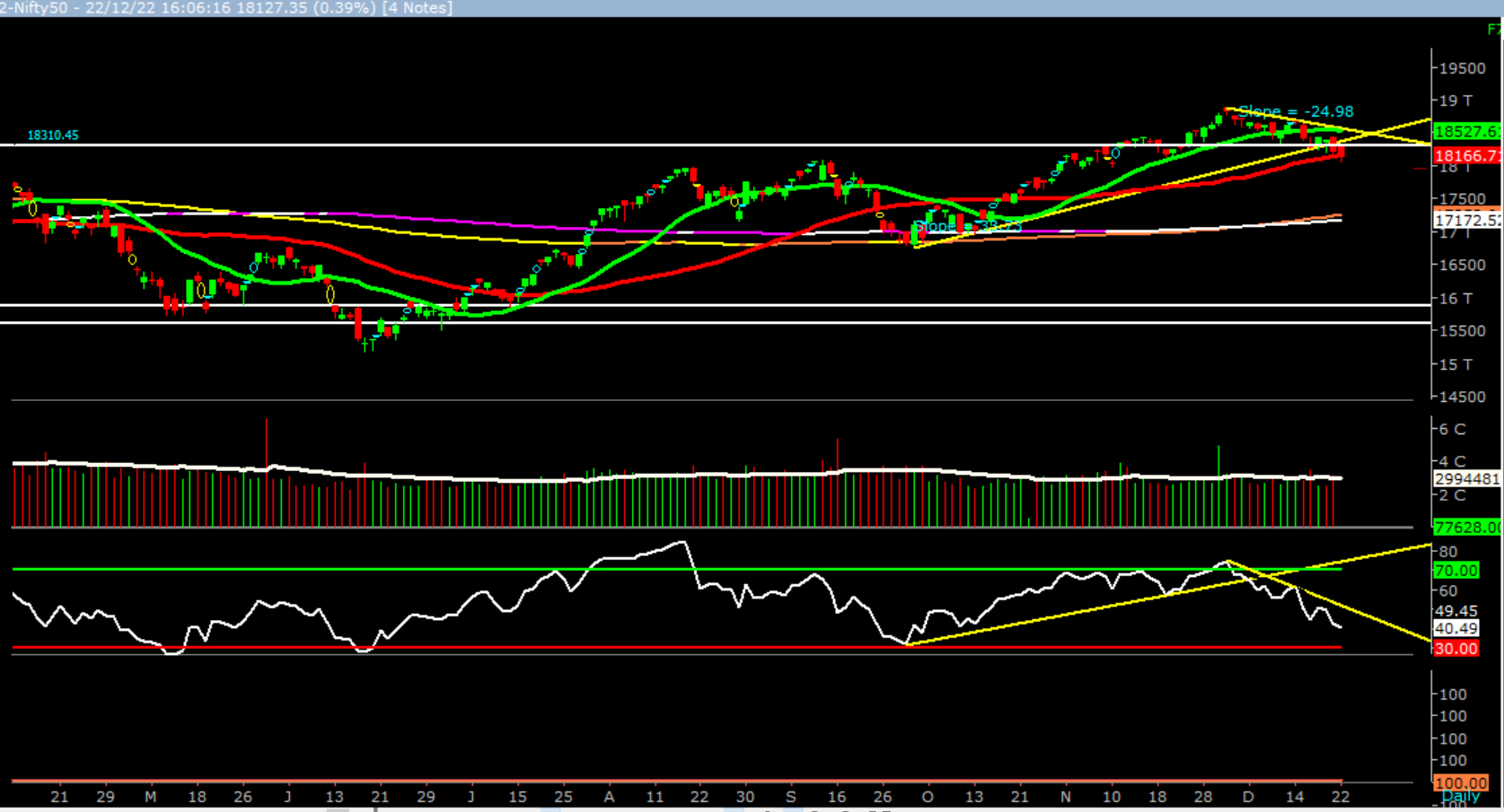  Nifty, opened higher but was unable to sustain the opening gains and momentum on the downside intensified as the day progressed which led nifty to close in red. At present, prices have close below the 50days SMA (18166). This suggests weakness. In coming trading session if nifty trades below 18050 then it may test 17940 – 17830 levels. However, a bounce from current level up to 18250 – 18360 cannot be ruled out.  Broadly, looking at the current price action we are of the opinion that 18600 – 18700 supply zone and 18000 – 17900 zone remain strong demand zone. Hence as long nifty holds the demand zone there is high probability that nifty may test the supply zone (18600 – 18700) or even extend the gains up to 19000– 19500 levels in couple of weeks.  Foreign Institutional Investments (FII's) Activities  Name of Segment Net Buyer/seller Rs In Cr  Index Futures Net Sell -650.59  Stock Futures Net Buy 737.76  Net Future Position Net Buy 87.17  Index Options Net Buy 10198.2  Stock Options Net Sell -155.45  Net Options Position Net Buy 10042.75  FII In cash Segment Net Buy 928.63  DII In cash Segment Net Buy 2206.59  Net Cash Position Net Buy 3135.22

Guru Call: From the expert’s desk
Company | Reco Date | Reco Price (Buy on dips) | High till date | Return%
Adani Power | 20-Apr-22 | 235 | 345 | 46.6%
Adani Wilmar Ltd | 20-Apr-22 | 668 | 878 | 31.5%
Aditya Birla Capital Ltd | 13-Aug-21 | 124 | 139 | 12.5%
Aditya Birla Fashion and Retail Ltd | 8-Feb-21 | 164 | 322 | 95.9%
Apcotex Industries Limited | 13-Aug-21 | 343 | 679 | 98.0%
Asian Paints Ltd. | 30-Mar-17 | 1068 | 3590 | 236.1%
Avenue Supermarts Ltd. | 31-Jul-17 | 899 | 5900 | 556.6%
Axis Bank Ltd. | 10-Apr-18 | 519 | 867 | 67.0%
Bajaj Finance Ltd | 20-Apr-22 | 7033 | 7295 | 3.7%
Bajaj Finserv Ltd | 1-Nov-16 | 3417 | 19325 | 465.6%
Bajaj Holdings And Investment Ltd | 19-May-16 | 1499 | 6598 | 340.1%
CDSL | 17-Sep-20 | 486 | 1734 | 256.9%
Chola finance | 25-Sep-20 | 239 | 770 | 222.6%
Chola Holding | 23-Sep-20 | 392 | 763 | 94.7%
Cipla Ltd | 20-Mar-17 | 597 | 1083 | 81.3%
Colgate Palmolive | 16-Sep-19 | 1314 | 1823 | 38.7%
D. P. Abhushan Ltd | 20-Apr-22 | 396 | 495 | 25.0%
Dabur India | 22-Oct-19 | 466 | 659 | 41.4%
DLF Ltd | 10-Apr-19 | 194 | 450 | 131.6%
Dr Reddy | 4-Aug-20 | 4530 | 5615 | 24.0%
Emami Limited | 26-Jun-19 | 290 | 622 | 114.2%
Finolex Cables Ltd | 8-Feb-21 | 130 | 268 | 106.2%
Fortis | 14-Jul-20 | 127 | 314 | 147.2%
Godawari Power | 20-Apr-22 | 455 | 482 | 6.0%
Godrej Consumer Products Limited | 16-Jun-20 | 634 | 1138 | 79.5%
HDFC Asset Management Company Ltd. | 19-Dec-18 | 1573 | 3844 | 144.4%
HDFC Bank Limited | 10-Nov-16 | 639 | 1725 | 170.0%
HDFC Life Insurance Co Ltd | 19-Jan-18 | 485 | 776 | 60.0%
Heritage Foods Ltd | 20-Apr-22 | 330 | 354 | 7.2%
Hero Motocorp Ltd | 29-Sep-20 | 3175 | 3629 | 14.3%
Hindustan Unilever Ltd. | 13-Nov-17 | 1291 | 2859 | 121.5%
Housing Development Finance Corp Ltd | 19-Dec-17 | 1720 | 3365 | 95.6%
ICICI Bank Ltd. | 6-Apr-18 | 279 | 867 | 211.1%
ICICI Lombard General Insurance | 19-Sep-19 | 1155 | 1675 | 45.0%
ICICI Prudential Life Insurance Company Ltd. | 28-Jun-18 | 376 | 724 | 92.7%
ICICI Securities Ltd | 24-Sep-20 | 467 | 896 | 92.0%
Indusindbnk | 8-Jun-20 | 451 | 1242 | 175.4%
Infosys Ltd. | 17-Aug-17 | 488 | 1954 | 300.7%
Kotak Mahindra Bank Ltd | 10-Nov-16 | 822 | 2253 | 174.1%
Linde India | 20-Apr-22 | 3499 | 3649 | 4.3%
Marico Ltd. | 4-Apr-18 | 325 | 608 | 87.1%
Maruti Suzuki India Ltd | 13-Aug-20 | 5989 | 9050 | 51.1%
Oberoi Realty Ltd. | 23-Nov-17 | 509 | 1052 | 106.8%
PEL | 2-Sep-20 | 1246 | 3015 | 141.9%
Phoenix Mills Limited | 7-Jul-19 | 655 | 1200 | 83.2%
Poonawalla Fincorp Ltd | 13-Aug-21 | 175 | 344 | 96.1%
Procter & Gamble Hygiene & Health Care | 13-Aug-21 | 12870 | 16466 | 27.9%
Raymond | 25-Sep-20 | 264 | 1280 | 385.7%
Reliance | 22-Apr-20 | 1351 | 2856 | 111.4%
SBI Life | 20-May-20 | 715 | 1293 | 80.8%
Shree Renuka Sugars Limited | 13-Aug-21 | 27 | 63 | 135.1%
Spectrum Electrical | 18-Apr-22 | 98 | 103 | 5.0%

Guru Call: From the expert’s desk
Company | Reco Date | Reco Price (Buy on dips) | High till date | Return%
State Bank of India | 3-Feb-21 | 336 | 549 | 63.4%
Sun Pharma | 7-Aug-20 | 525 | 967 | 84.2%
Sun TV Network Ltd. | 13-Aug-21 | 525 | 612 | 16.5%
Tata Chemicals Limited | 24-Dec-19 | 297 | 1158 | 290.0%
Tata Consultancy Services Ltd. | 8-Jan-18 | 1345 | 4046 | 200.9%
Tata motors | 20-Apr-22 | 441 | 450 | 2.0%
Tata motors dvr | 20-Apr-22 | 220 | 226 | 2.6%
Tata Power | 20-Apr-22 | 249 | 260 | 4.4%
Trent Ltd. | 19-Dec-18 | 348 | 1347 | 286.6%
Ultratech Cement Ltd. | 19-Dec-18 | 4085 | 8269 | 102.4%
UTI Asset Management Company Ltd | 13-Aug-21 | 1044 | 1217 | 16.6%
Vedanta Ltd | 28-Jun-21 | 261 | 441 | 69.1%
Voltas Ltd. | 27-Mar-18 | 614 | 1357 | 121.0%
Whirlpool Of India Ltd. | 7-Dec-16 | 872 | 2550 | 192.3%
Wipro Limited | 13-Aug-21 | 616 | 740 | 20.2%

NIFTY 50 STOCKS BELOW 200SMA
SCRIP NAME | SMA 200 | CLOSING (22-12-2022)
INFY | 1556.69 | 1522.05
WIPRO | 448.69 | 388.75
TATASTEEL | 108.85 | 107.65
TATAMOTORS | 428.59 | 394.45
BPCL | 331.37 | 327.9
ASIANPAINT | 3110.39 | 3088.55
ONGC | 145.47 | 142.25
UPL | 743.59 | 729.35
BAJFINANCE | 6686.54 | 6490.65
POWERGRID | 220.6 | 215
DIVISLAB | 3794.64 | 3495.9
TCS | 3323.16 | 3259.7
TECHM | 1135.81 | 1015.85
MARUTI | 8369.12 | 8334.35
BAJAJ-AUTO | 3742 | 3600.85
-- | -- | --
-- | -- | --
-- | -- | --
-- | -- | --
-- | -- | --
-- | -- | --
-- | -- | --
-- | -- | --
-- | -- | --
-- | -- | --
-- | -- | --
-- | -- | --
-- | -- | --
-- | -- | --
-- | -- | --
-- | -- | --
-- | -- | --
-- | -- | --
-- | -- | --

Weekly Expiry Most Active Nifty Call Option
Symbol | Expiry Date | Strike Price | Highest Open Interest (Contracts)
NIFTY | 29-Dec-2022 | 19000 | 1,69,943
NIFTY | 29-Dec-2022 | 18500 | 1,35,513
NIFTY | 29-Dec-2022 | 18400 | 1,14,791

Weekly Expiry Most Active Nifty Put Option
Symbol | Expiry Date | Strike Price | Highest Open Interest (Contracts)
NIFTY | 29-Dec-2022 | 18000 | 1,15,423
NIFTY | 29-Dec-2022 | 18200 | 98,475
NIFTY | 29-Dec-2022 | 17500 | 95,478

Securities in Ban For Trade Date 23-12-2022
IBULHSGFIN
Bulk Deals (BSE)
NA
Bulk Deals (NSE)
Deal Date | Scrip Name | Client Name | Deal Type | Quantity | Price
22-Dec-22 | AJANTPHARM | ICICI PRUDENTIAL MUTUAL FUND | BUY | 1086110 | 1,160.10
22-Dec-22 | AJANTPHARM | NIPPON INDIA MUTUAL FUND | BUY | 715450 | 1,160.10
22-Dec-22 | SULA | JUPITER INDIA FUND | BUY | 632155 | 361.00
22-Dec-22 | SULA | GOLDMAN SACHS FUNDS GOLDMAN SACHS INDIA EQUITY | BUY | 695864 | 351.48
22-Dec-22 | AJANTPHARM | AAYUSH AGRAWAL TRUST | SELL | 3853959 | 1,160.10
22-Dec-22 | AJANTPHARM | RAVI AGRAWAL TRUST | SELL | 1638887 | 1,160.10
22-Dec-22 | THYROCARE | BAJAJ ALLIANZ LIFE INSURANCE COMPANY LTD | SELL | 275000 | 659.69

Note- Executed on 22nd Dec 2022. Bulk Deal Buy/Sell done by fund house is considered.

IPO LISTING

IPO Listing Today: Company Name: “ABANS HOLDINGS LIMITED”, BSE CODE: 543712, NSE Symbol: AHL, Issue Price: Rs 270 per share, Series: EQ

IPO Listing Today: Company Name: “LANDMARK CAR LIMITED”, BSE CODE: 543714, NSE Symbol: LANDMARK, Issue Price: Rs506 per share, Series: EQ

Research Analyst Registration No. | Contact | Website | mail Id
INH000002764
 | SMS: ‘Arihant’ to 56677 | www.arihantcapital.com | arihant.research@arihantcapital.com

Arihant is Forbes Asia’s ‘200 Best under a $Billion’ Company
‘Best Emerging Commodities Broker’ awarded by UTV Bloomberg
Disclaimer: This document has been prepared by Arihant Capital Markets Limited (hereinafter called as Arihant) and its subsidiaries and associated companies. This document does not constitute an offer or solicitation for the purchase and sale of any financial instrument by Arihant. Receipt and review of this document constitutes your agreement not to circulate, redistribute, retransmit or disclose to others the contents, opinions, conclusion, or information contained herein. This document has been prepared and issued on the basis of publicly available information, internally developed data and other sources believed to be reliable. Whilst meticulous care has been taken to ensure that the facts stated are accurate and opinions given are fair and reasonable, neither the analyst nor any employee of our company is in any way is responsible for its contents and nor is its accuracy or completeness guaranteed. This document is prepared for assistance only and is not intended to be and must not alone be taken as the basis for an investment decision. All recipients of this material should before dealing and or transacting in any of the products referred to in this material make their own investigation, seek appropriate professional advice. The investments discussed in this material may not be suitable for all investors. The recipient alone shall be fully responsible/are liable for any decision taken on the basis of this material. Arihant Capital Markets Ltd (including its affiliates) or its officers, directors, personnel and employees, including persons involved in the preparation or issuance of this material may; (a) from time to time, have positions in, and buy or sell or (b) be engaged in any other transaction and earn brokerage or other compensation in the financial instruments/products discussed herein or act as advisor or lender/borrower in respect of such securities/financial instruments/products or have other potential conflict of interest with respect to any recommendation and related information and opinions. The said persons may have acted upon and/or in a manner contradictory with the information contained here and may have a position or be otherwise interested in the investment referred to in this document before its publication. The user of this report assumes the entire risk of any use made of this data/report. Arihant especially states that it has no financial liability, whatsoever, to the users of this report.

Arihant Capital Markets Ltd
#1011 Solitaire Corporate Park Building No.10 1st Floor
Andheri Ghatkopar Link Road Chakala Andheri (E) Mumbai-400093
T. 022-42254800. Fax: 022-42254880
www.arihantcapital.com

